1

3D Shapes
In this chapter you will learn how to use the OpenSCAD programming language to draw basic 3D shapes. You will also learn how to move those shapes around in 3D space, as well as different operations that will allow you to combine multiple basic shapes into one complex object. Big projects from this section will ask you to apply these concepts as you design objects that are useful for calibrating a 3D printer.

OpenSCAD Environment Basics
OpenScad is a text-based programming language that makes 3D design very straight-forward and easy. Designing 3D objects with OpenSCAD is a two-step process:
  - Type code command to describe your object in the Editor window:
Insert Figure01-01.png here
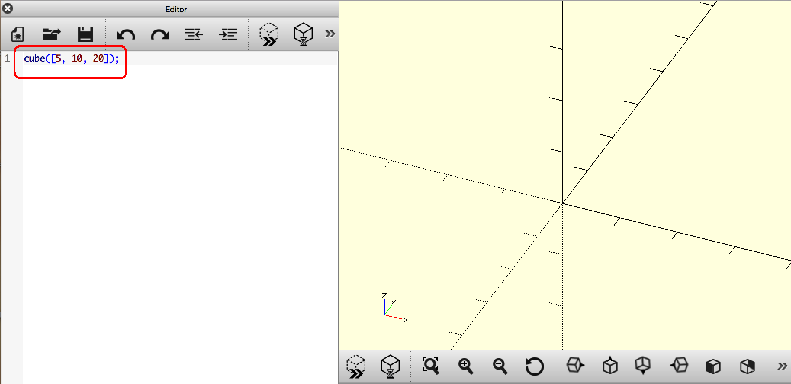
Figure 1-1: The Editor Window
  - Draw your object with the Preview button.
Insert Figure01-02.png here
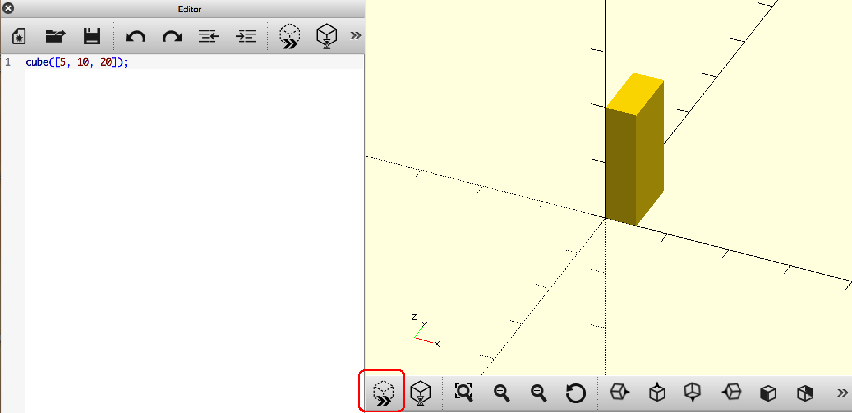
Figure 1-2: The Preview Button
There are many other buttons on this Toolbar, and those options will be introduced soon. For right now you can use your left-click-and-drag with your mouse to check out your shapes from many different viewpoints.

Drawing Basic 3D Shapes
OpenSCAD code allows you to write instructions for your computer to draw 3D (and 2D) shapes. Commands to draw basic 3D shapes (cuboids, spheres, cylinders, cones, and imported models) are all quite similar.

Drawing Cuboids with cube
Let's take a closer look at the OpenSCAD code from above:
cube1.scad
cube([5, 10, 20]);
This OpenSCAD instruction can be translated into English as such: “Draw a cube that extends 5 units along the x-axis, 10 units along the y-axis, and 20 units along the z-axis.” As the sides are all different measures, this shape is more similar to a 3D rectangle than a cube. To help avoid confusion I'll call this shape a cuboid throughout the book. All cuboids have a width, length, and height; any of the three dimensions may be different or the same.
The OpenSCAD cube command allows you to create a cuboid of any size. It follows this format:
cube([, , ]);
cube is used to indicate that you want to draw a cuboid. The ( )'s are used to modify the cube command so that OpenSCAD knows how big you want your cuboid to be. The [ ]'s indicate a vector, and are used to group together the dimensions of your cuboid:  is the width of the cuboid along the x-axis,  is the length of the cuboid along the y-axis, and  is the height of the cuboid along the z-axis. Finally, a ; is used as punctuation mark to end a single command.
Here are two more examples of the cube command in action:
cube_2.scad
cube([30, 10, 5]);
Insert cube_2.png here
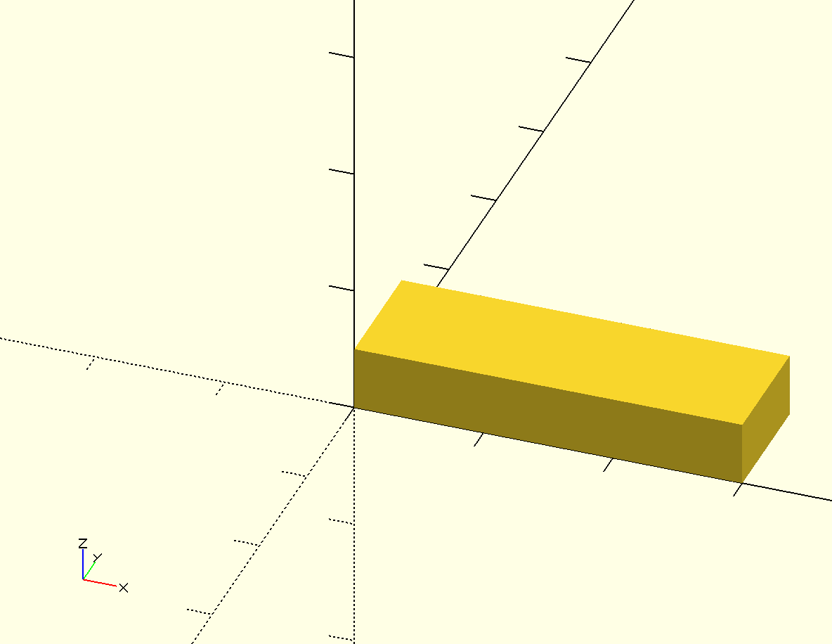
Figure cube_2: A second cuboid example: width - 30, length - 10, height - 5
cube_3.scad
cube([20, 20, 20]);
Insert cube_3.png here
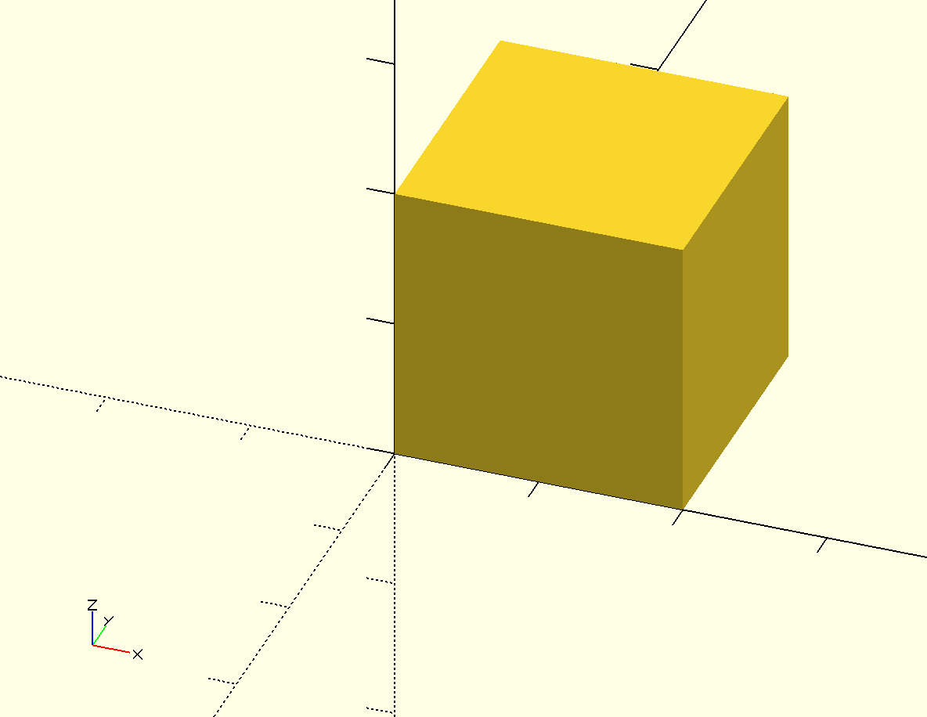
Figure cube_3: A third cuboid example: width – 20, length – 20, height – 20
Notice that each cuboid is positioned such that one corner touches the origin: (0, 0, 0)

Drawing Spheres with sphere
Drawing a sphere in OpenSCAD is even easier than drawing a cuboid:
sphere();
sphere is used to indicate that you want to draw a sphere. The ( )'s are used to modify the sphere command so that OpenSCAD knows how big you want your sphere to be:  is the radius of the sphere.
Here is an example of the sphere command in action:
sphere.scad
sphere(10);
Insert sphere.png here
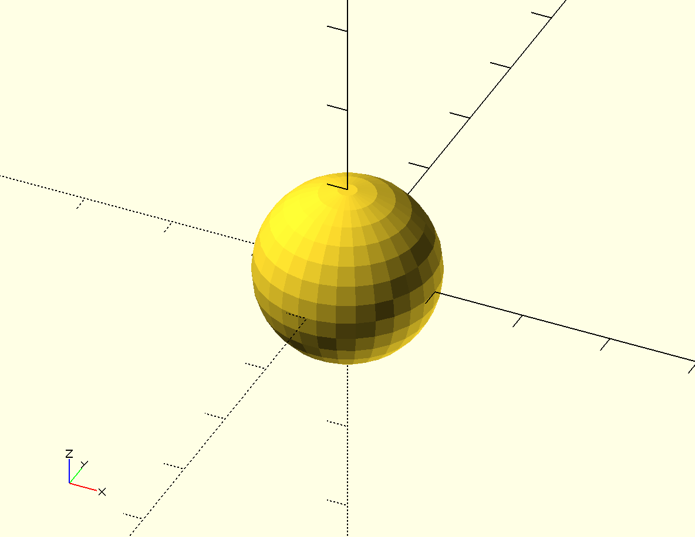
Figure sphere: A sphere example: radius – 10
Changing the size of the radius is the only one way you can change the shape of a sphere. That is why the basic sphere command only has one number inside of the ( )'s. As with the cube command, a ; is used as punctuation mark to end the command.
Notice also how the sphere is centered around the origin: (0, 0, 0). This is a bit different from the behavior of the cube command.

Drawing Cylinders and Cones with cylinder
To draw a cylinder in OpenSCAD, you must indicate both the height of the cylinder and the radii of the circles that form the top and bottoms of the cylinder:
cylinder.scad
cylinder(h=20, r1=5, r2=5);
Insert cylinder.png here
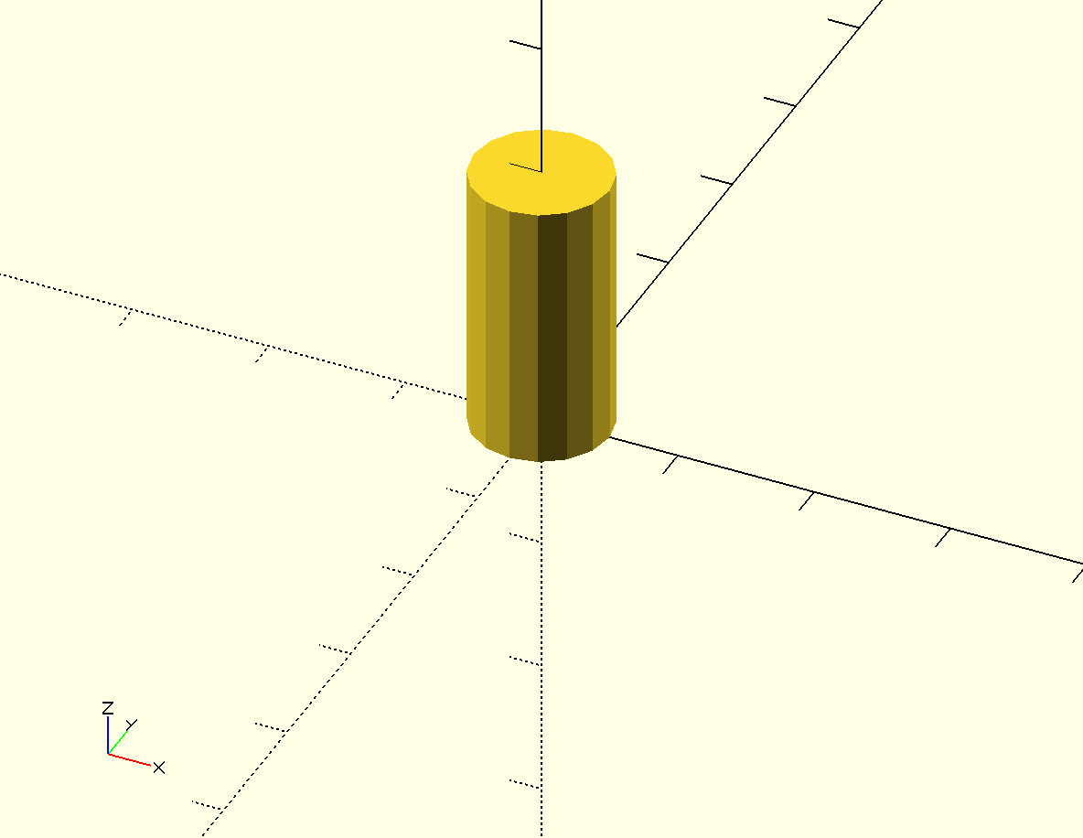
Figure sphere: A cylinder example: height = 20, bottom radius – 5, top radius – 5
The cylinder command follows this format:
cylinder(h=, r1= r2=);
The cylinder command is modified by indicating three values inside of the( )'s:  is the height of the cylinder along the z-axis,  is r1 - the radius of the bottom of the cylinder, and  is r2 - the radius of the top of the cylinder. As with the other two commands, a ; is used as punctuation mark to end the command.
Notice also how the cylinder is centered around the origin: (0, 0, 0). This is similar to the behavior of the sphere command.
Here are two examples that demonstrate how you would use the command to draw a cone:
cylinder(h = 20, r1=5, r2=3);
Insert cone.png here
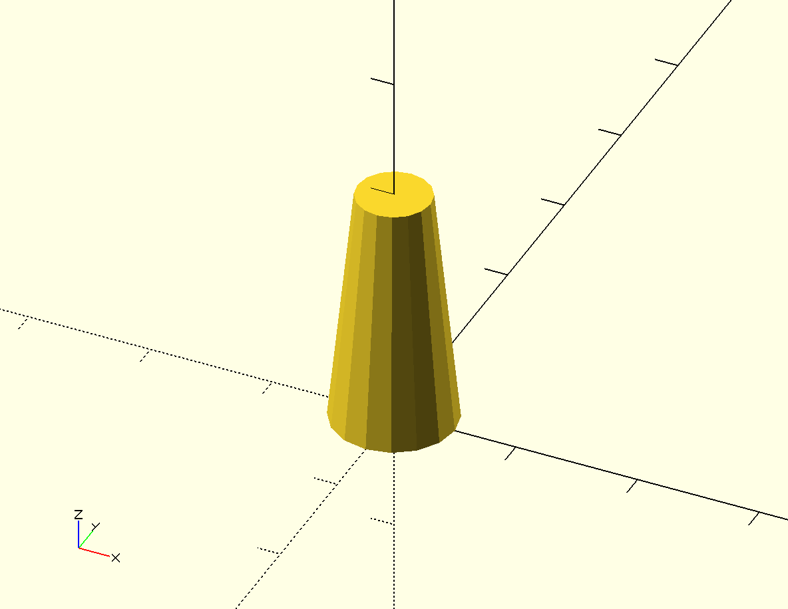
Figure cone: A cone example: height = 20, bottom radius – 5, top radius – 3
cone_upside_down.scad
cylinder(h = 20, r1=0, r2=5);
Insert cone_upside_down.png here
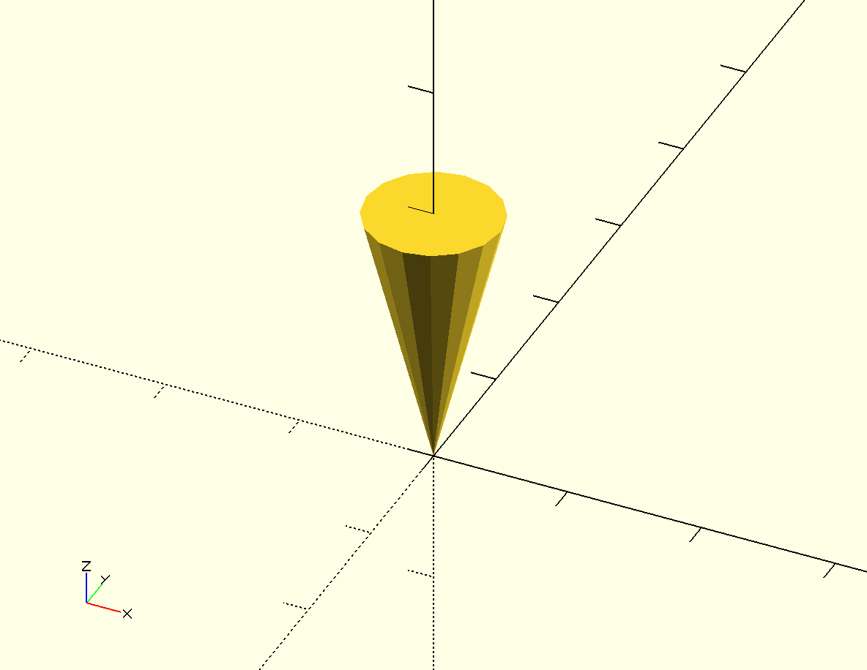
Figure cone_upside_down: An upside down cone example: height = 20, bottom radius – 0, top radius – 5

Importing 3D Models with import
Finally, OpenSCAD allows you to import 3D shapes saved in the .stl format from other 3D design programs with the import command:
import.scad
import("3DBenchy.stl");
Insert import.png here
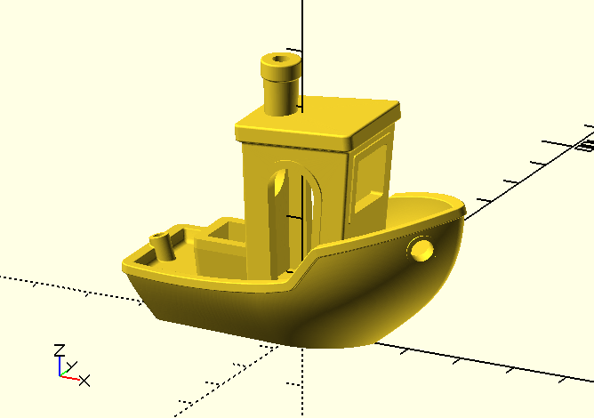
Figure import: An imported 3D image of 3DBenchy.stl
Tell the import command which .stl file you'd like to import by including the name of the file inside of the( )'s. The .stl file you'd like to import should be saved in the same location/directory as your OpenSCAD program. As by now you might suspect, a ; is used to end the command.
The import command centers the imported shape around the origin: (0,0,0).

Basic Shape Modifications
In addition to changing the size of a shape, there are two other ways to make basic changes to the shapes you draw with OpenSCAD.

Moving Objects
If the object you are creating has more than one shape, you'll definitely want to know how to move individual shapes around the Drawing window.
      - Centering Cuboids with center=true
By default the cube command draws a cuboid with one corner touching the origin. All of the other shapes you learned to code get centered around the origin, so that the (0, 0, 0) is the center point in the shape. What if you want to draw a cuboid that's centered around the origin?
To quickly draw a cuboid that's centered around the origin, modify the cube command with one extra component inside of the( )'s:
cube_1_centered.scad
cube([5, 10, 20], center=true);
Insert cube_1_centered.png here
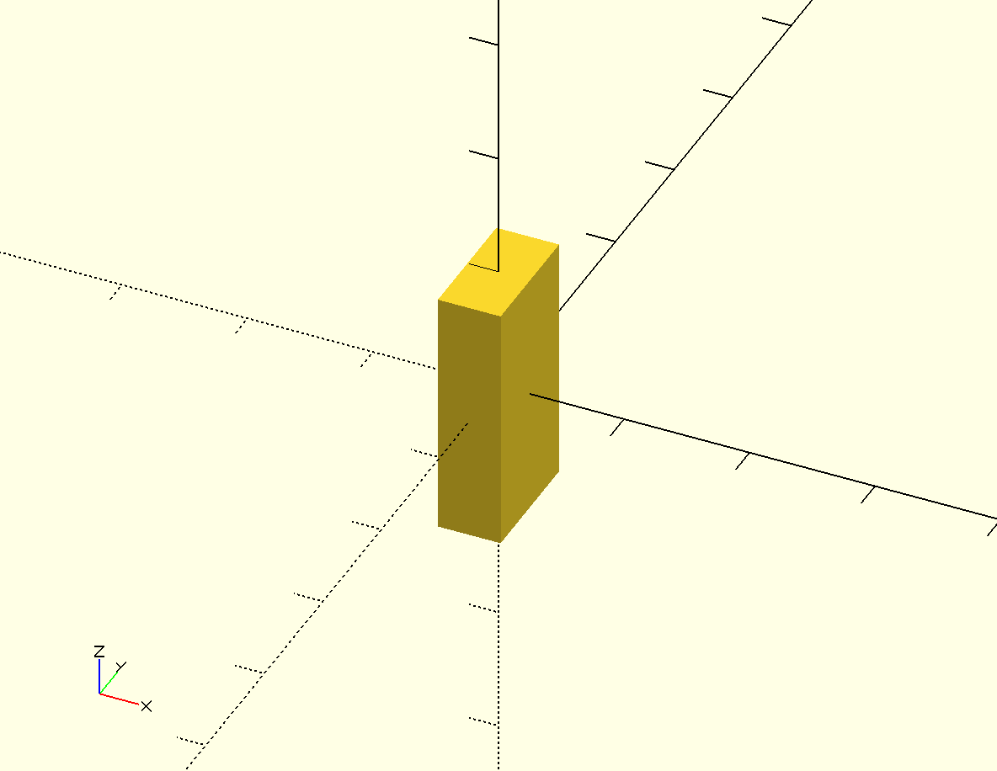
Figure cube_1_centered: A centered cuboid with width - 5, length - 10, height - 20
Compare this centered cuboid to the first cuboid you drew:
Insert cube.png here
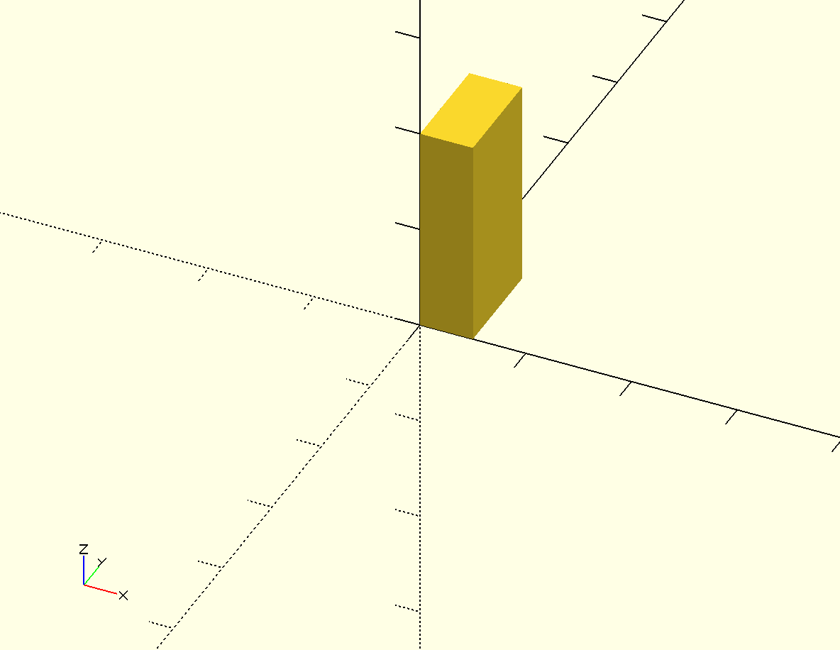
Figure cube: A default cuboid with width - 5, length - 10, height - 20
      - Moving Shapes to a Specific Location with translate
As you learn to build complex objects by combining multiple primitive shapes, you will want to know how to move a shape to a specific spot in the Drawing window. This operation is called translate:
translate_cube.scad
translate([-10, 20, 0]) cube([20,10,10]);
Insert translate_cube.png here
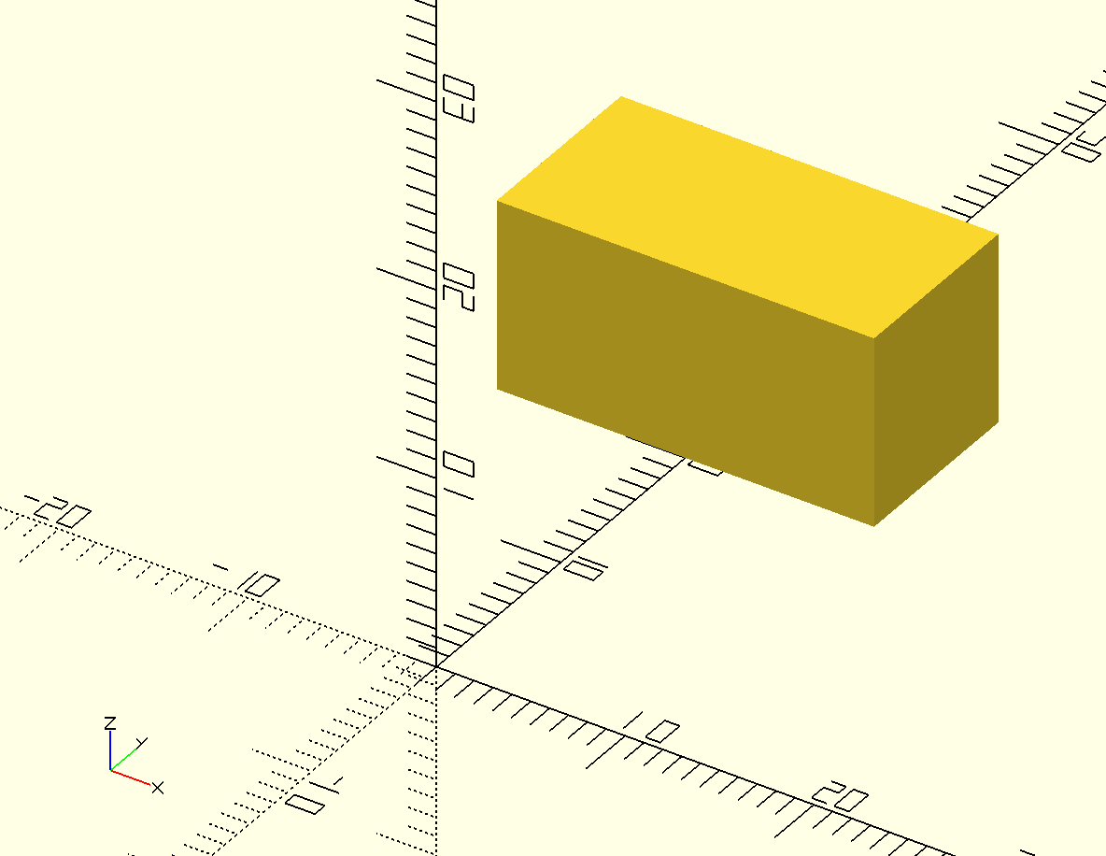
Figure translate_cube: A translated cuboid with a starting corner at (-10, 20, 0)
The translate command modifies a shape command, so is included just before the shape it is meant to modify. Notice how translate uses [ ]'s to group the three different dimensions of possible movement into a vector. The above example moves the cuboid 10 units in the negative direction along the x-axis, 20 units in the positive direction along the y-axis, and 0 units along the z-axis:
Insert translate_cube_diagram.png here
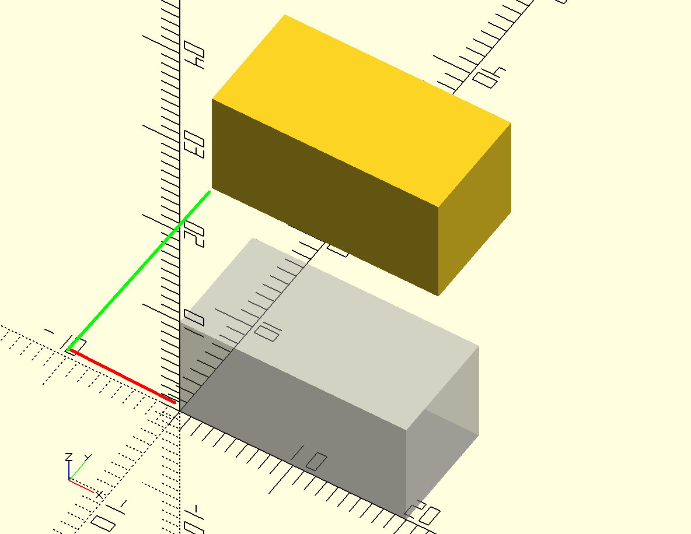
Figure translate_cube_diagram: A cuboid moved -10 units along the x-axis and 20 units along the y-axis
Here's how translate works:
translate([, , ]) cube([20,10,10]);
The ( )'s are used to modify the translate command so that OpenSCAD knows how far you want to move your shape along each of the three axes. The [ ]'s indicate a vector, and are used to group together the dimensions of the movement:  is the amount of movement along the x-axis,  is the amount of movement along the y-axis, and  is the amount of movement along the z-axis. Notice how the ; is used to end the entire command.
Include the translate command in front of each shape that you want to move:
translate_multiple.scad
translate([-10, 10, 0]) cube([20,10,10]);
translate([10, -10, 10]) sphere(5);
translate([0, 0, -10]) cylinder(h=30, r1=2, r2=2);
Insert translate_multiple.png here
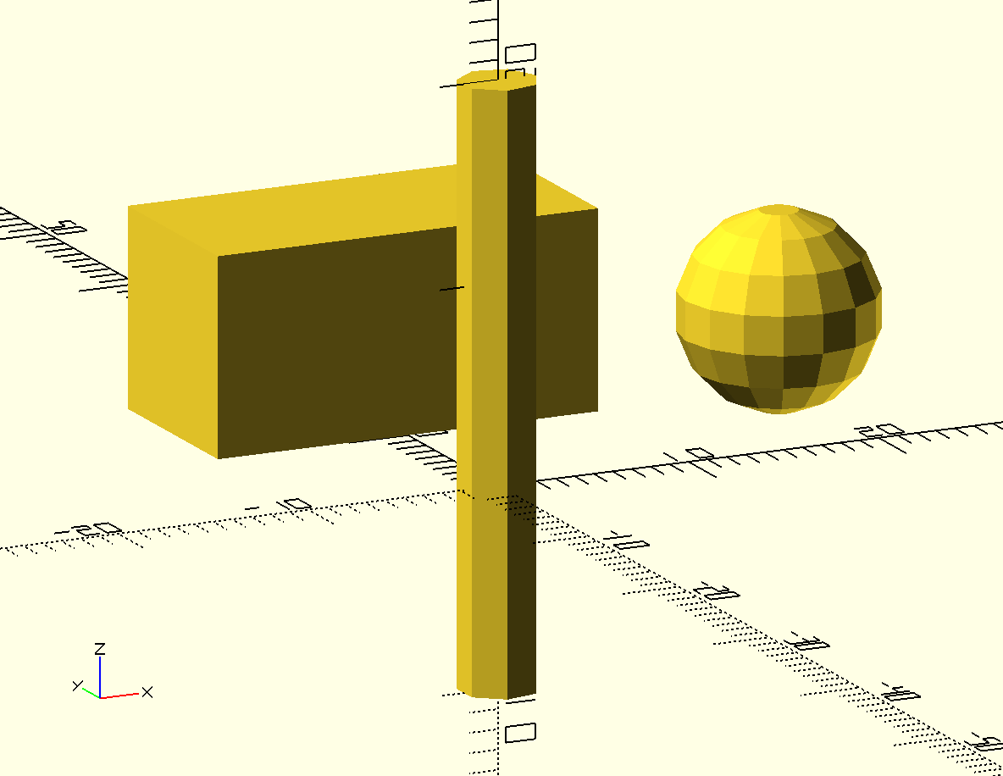
Figure translate_multiple: Three translated shapes: cuboid, sphere, and cylinder
Notice how both the sphere and cylinder are moved according to their center point. That's because both of those shapes are centered by default.

Smoothing Curves with $fn
You might be wondering why the spheres and cylinders you've drawn so far don't appear to be “round”. The reason why is complicated, but it is based on the fact that OpenSCAD (and most 3D design software) uses a collection of straight lines to approximate a curve. To save memory and processing time to draw complex shapes, OpenSCAD uses a relatively small number of lines by default. In fact, the cylinder in our last example is drawn using six line segments to approximate the curve of the circular faces of the cylinder.
OpenSCAD allows you to specify the number of line segments used to approximate a curve so that you can make your cylinders and spheres appear round. Use the $fn variable to set the number of line segments you'd like to use at the top of your OpenSCAD code:
smoothing_10_lines.scad
$fn=10;
cylinder(h=30, r1=2, r2=2);
Insert smoothing_10_lines.png here
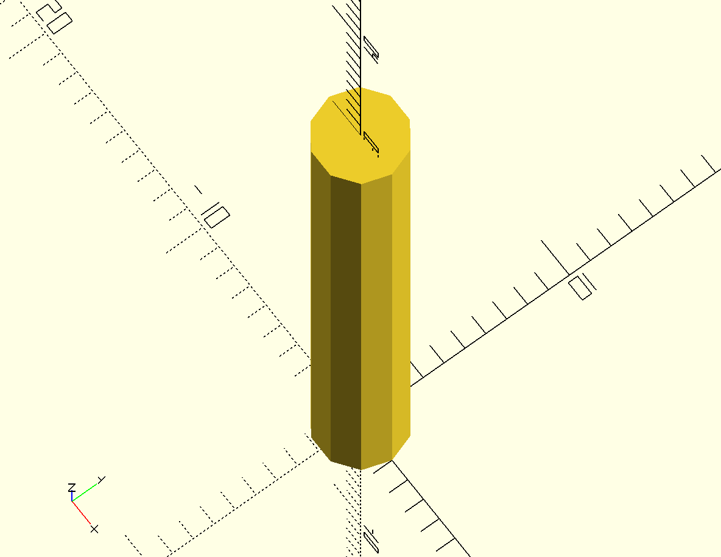
Figure smoothing_10_lines: A cylinder using 10 line segments to approximate the circle
This cylinder looks a bit more round because now OpenSCAD is using 10 line segments to draw the circular faces of the cylinder. Increase the $fn value a lot to visibly increase the roundness of your shapes:
smoothing_50_lines.scad
$fn=50;
cylinder(h=30, r1=2, r2=2);
Insert smoothing_50_lines.png here
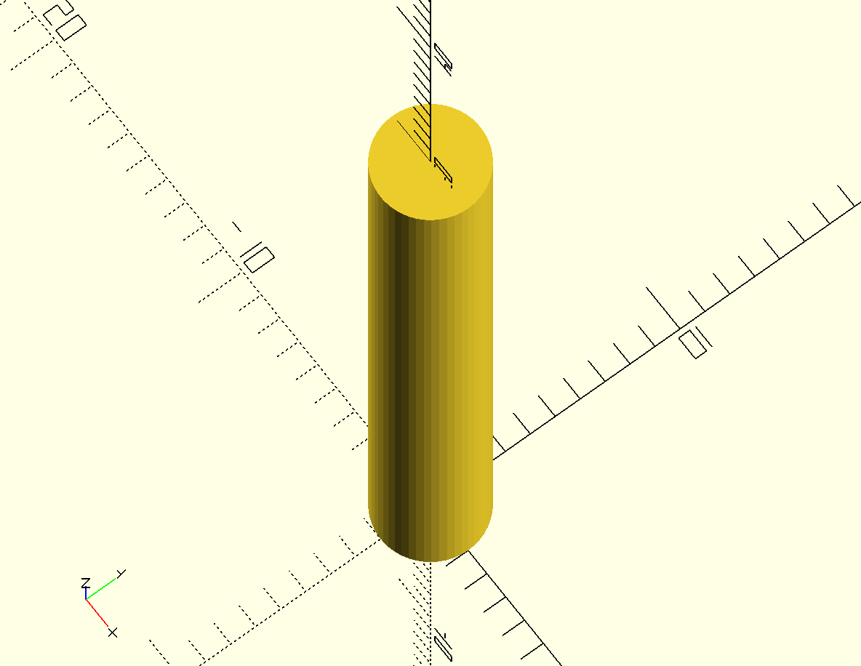
Figure smoothing_50_lines: A cylinder using 50 line segments to approximate the circle
This cylinder looks a lot smoother because OpenSCAD is now using 50 line segments to draw the circular faces of the cylinder.

Combining 3D Shapes with Boolean Operations
One of the most powerful features of 3D design is the ability to combine multiple shapes using three different operations: union, difference, and intersection

Grouping Shapes with union
Sometimes it's useful to group multiple shapes together. This allows you to refer to the collection of shapes as one entity. To group shapes together, use the union operation:
union.scad
union(){
cube([10,10,10]);
sphere(5);
}
Insert union.png here
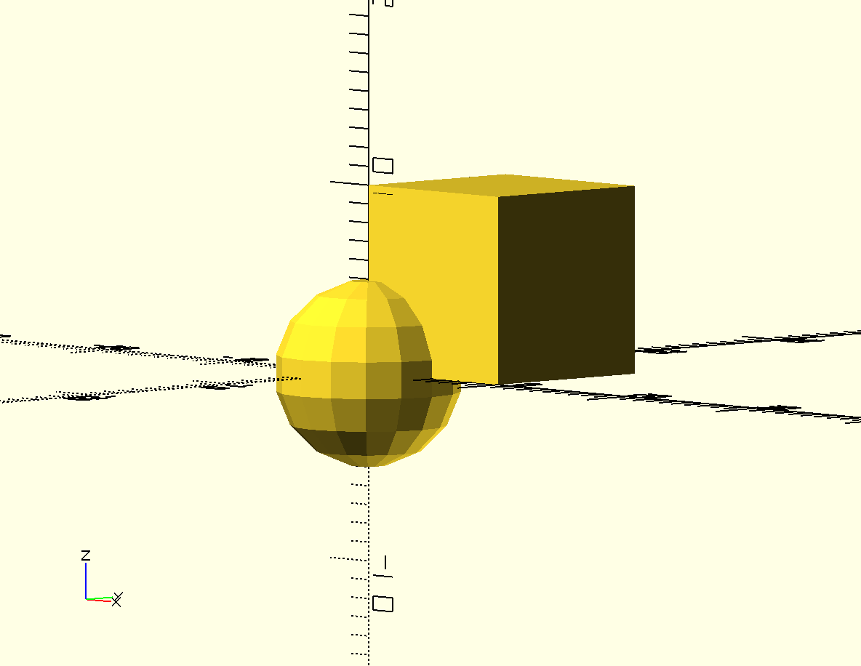
Figure union: A sphere and a cuboid grouped together
The union operation groups together all of the shapes that are inside of the{ }'s. There is no need to modify the union operation, so you will never need to put any extra information inside of the ( )'s.
Why would you do this? For instance, what if you want to move multiple shapes at once? You could translate each shape individually, or group all of the shapes together to move them all at once:
union_translated.scad
translate([5, 5, 5])
union(){
cube([10,10,10]);
sphere(5);
}
Insert union_translated.png here
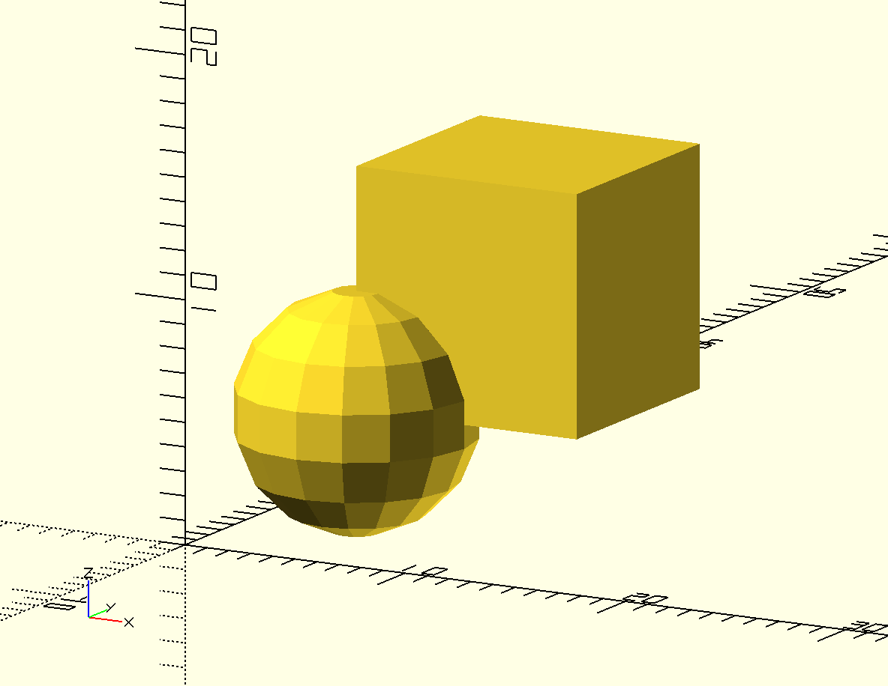
Figure union_translated: A translated sphere and a cuboid that were grouped together
The translate command modifies the entire grouped collection of shapes so that you can refer to both individual shapes as a single object.

Subtracting Shapes with difference
difference_1.scad
difference(){
cube([10,10,10]);
sphere(5);
}
Insert difference_1.png here
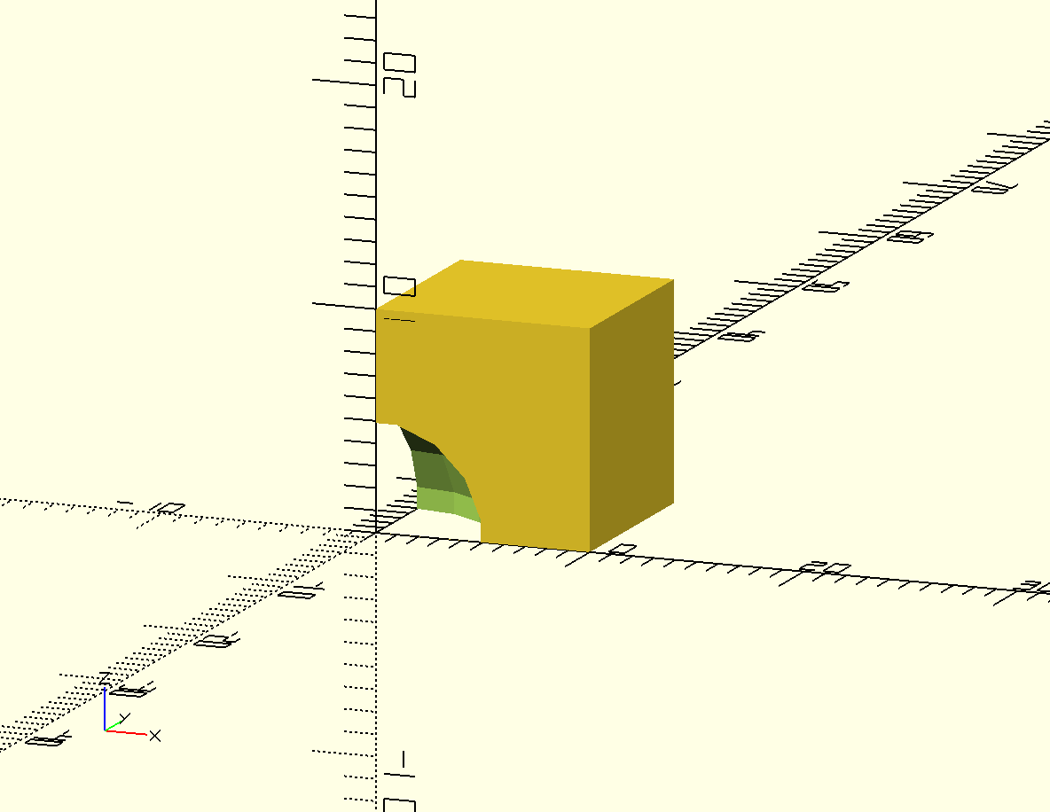
Figure difference_1: A sphere subtracted from a cuboid

difference_2.scad
difference(){
sphere(5);
cube([10,10,10]);
}
Insert difference_2.png here
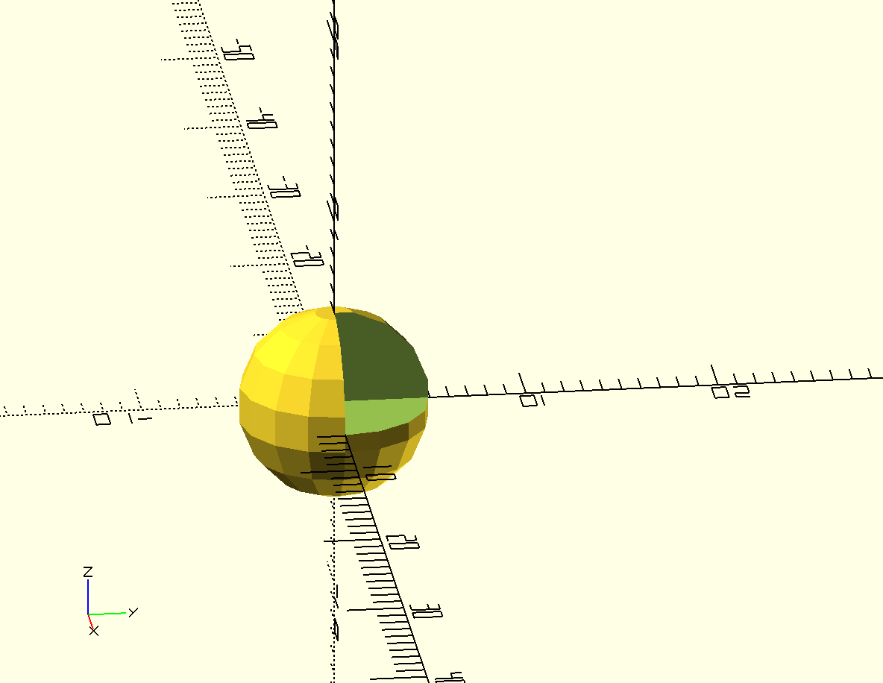
Figure difference_2: A cuboid subtracted from a sphere

Carve Overlapping Sections with intersection
intersection.scad
intersection(){
sphere(5);
cube([10,10,10]);
}
Insert intersection.png here
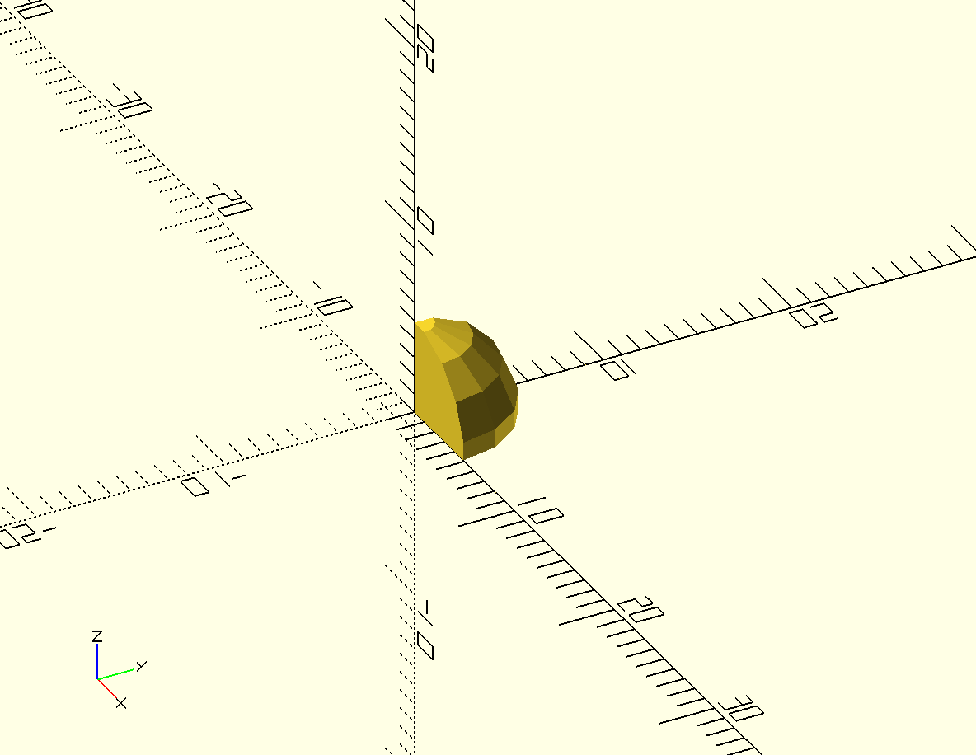
Figure intersection: The overlapping cutout of a cuboid and a sphere

Constructive Solid Geometry
csg.scad
difference(){
cube([10,10,10]);
#sphere(5);
}
Insert difference_1.png here
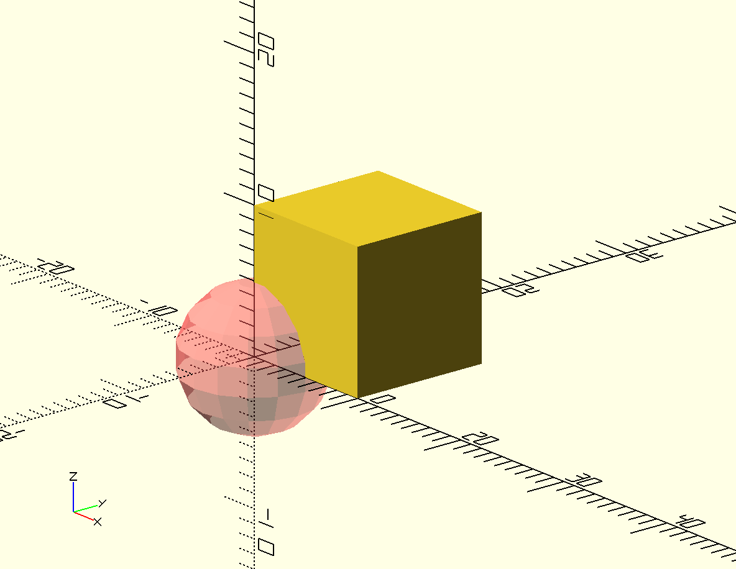
Figure csg: A ghost-version of a subtracted sphere to help with problem solving

Design Time
Mouse
insert Mouse.png here
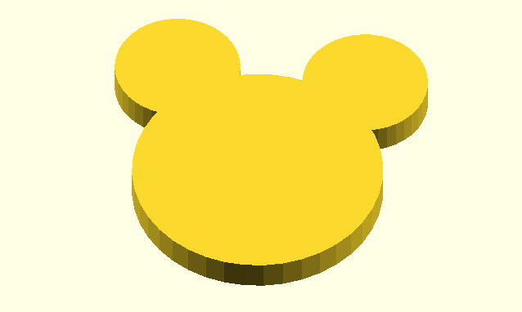
Figure mouse: A Simple Profile of a Mouse
Yo-Yo
insert Yo-Yo.png here
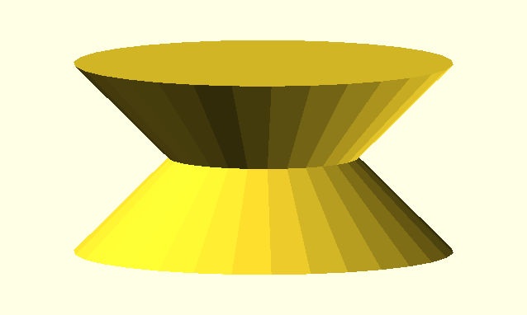
Figure Yo-Yo: A Simple Yo Yo Toy
Spinner
insert Spinner.png here
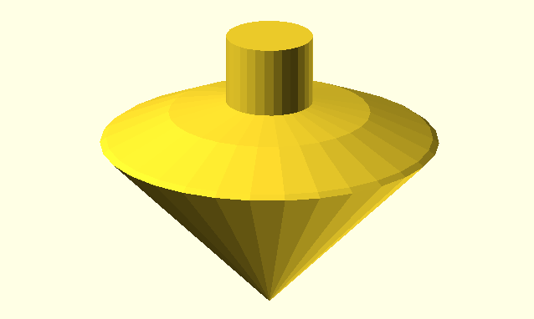
Figure Spinner: A Spinner Toy
Epcot
insert Epcot.png here
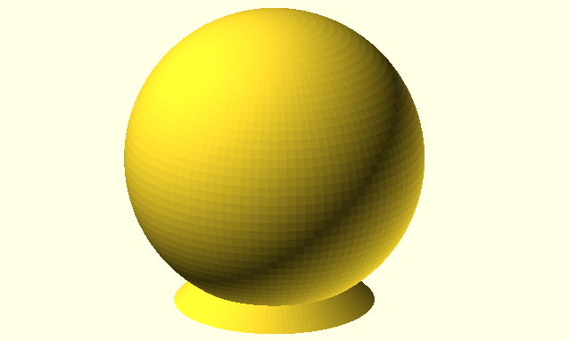
Figure Epcot: A Simple Model of the Epcot Center
Halfpipe
insert Halfpipe.png here
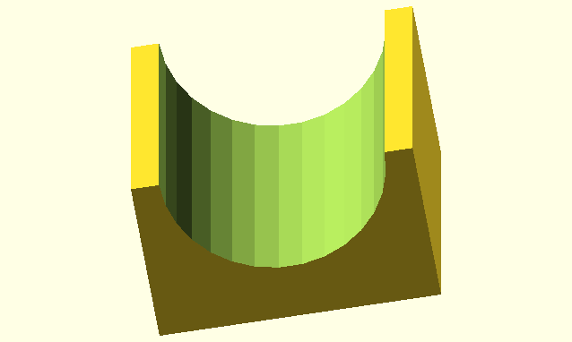
Figure halfpipe: A Halfpipe Ramp
Ice Cream Cone
insert Ice-Cream-Cone.png here
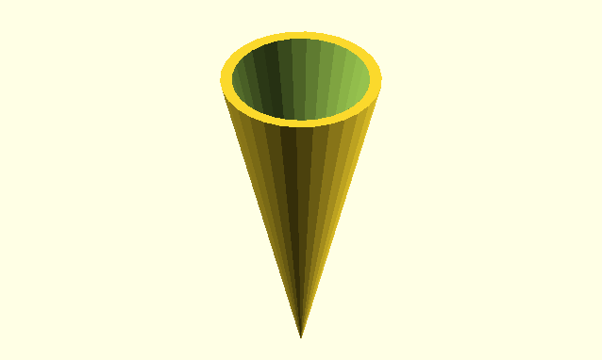
Figure ice-cream-cone: An Ice Cream Cone
BullsEye
insert Bullseye.png here
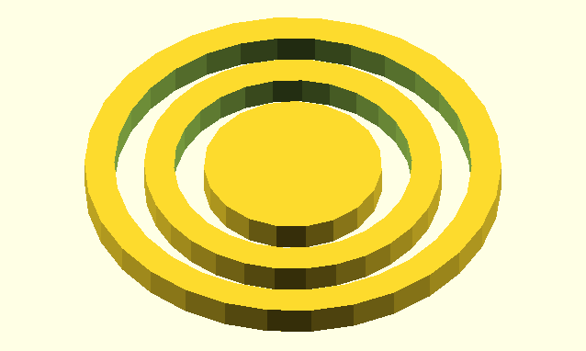
Figure bullseye: A Bullseye

Important Stuff
You now know how to:
type OpenSCAD code into the Editor window
preview objects in the Drawing window
draw cuboids, spheres, and cylinders in any size
import 3D objects in the .stl file format
smooth curves
move shapes to anywhere along the X, Y, and Z axes
group shapes
subtract and cutout overlapping shapes

Here are some important tips:
The name of a command tells you which type of shape you'd like to draw.
;'s are used is used to end a command.
Information inside of ( )'s are used to modify commands.
[ ]'s collect numbers together to form a vectors.
Boolean operations use { }'s to collect multiple shapes together .
( )'s, [ ]'s, and { }'s always come in pairs.
OpenSCAD is unit-less.
Set $fn at the beginning of your code to generate smooth curves.
Use the translate command to move your shapes.
Use indentation to help make your code readable and easy to understand.

Big Projects
Calibration Pyramid
insert Calibration-Pyramid.png here
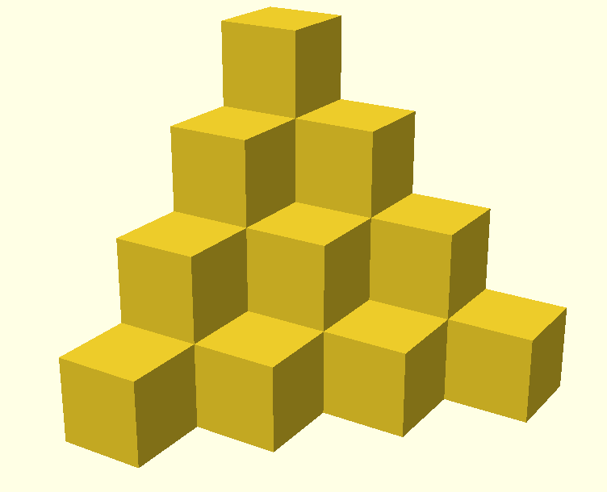
Figure Calibration Pyramid: A Calibration Pyramid
Hole and Pins Test
insert Hole-and-Pin-Test.png here
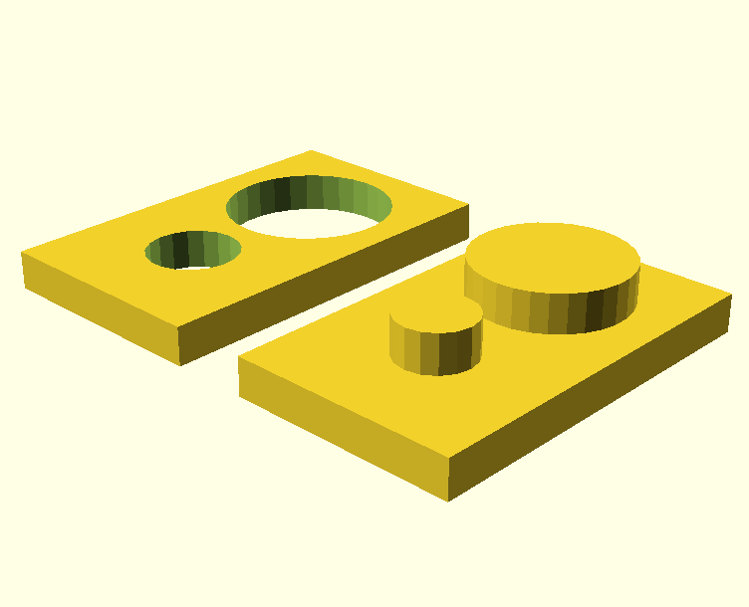
Figure hole and pin test: A Hole and Pin Test
Smiley Face Pendant
insert Smiley-Face.png here

Figure smiley-face: A Smiley Face Pendant

Questions
How do I indicate one word of code embedded within the body text should be formatted as code?
Can we put the pictures next to the code instead of beneath the code? Perhaps with an invisible table? It would save a lot of space. Related to this, what is the recommended smallest picture size?
The illustration numbering schema is problematic since we have so many pictures. If we change the ordering at all every label after the change will be incorrect.
Reset view doesn't include minor tick marks. All of the images in the first three chapters should include the minor tick marks to help readers visualize exact positioning on the 3D axis.

